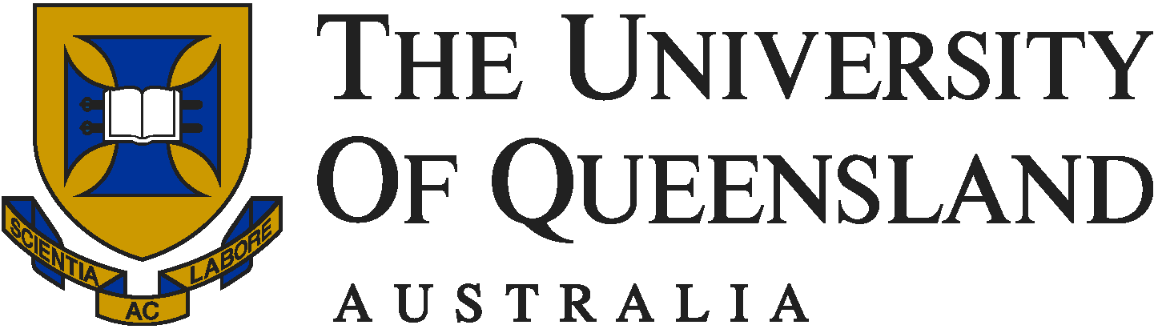


Asian Studies Association
of Australia

Ninth International Women in Asia Conference

29 September to 1 October 2008

Call for Papers and Call for Nominations for Emerging Researchers Showcase

Registration is now open. Full details via the Women in Asia Conference link at http://www.arts.uq.edu.au/slccs/
Email: wia@uq.edu.au
The Ninth Women in Asia (WIA) Conference will be hosted by the School of Languages and Comparative Cultural Studies, University of Queensland from 29 September to 1 October 2008. WIA conferences have been held regularly since 1981 and are supported by the Women’s Forum of the Asian Studies Association of Australia. Participants include academics and students; representatives of NGOs and other organisations involved in aid and development; artists and performers; and interested members of the general public. The conference provides excellent opportunities for networking and getting to know others in the field.
The theme for the 2008 conference is Transition and Interchange, which we hope will stimulate discussion on temporal and geo-cultural changes and interactions that may be understood in many different ways and in many different contexts.
Contributions are invited from a broad range of participants from various disciplines on a large number of themes concerning the lives of women in Asia. Participants are encouraged to submit proposals for panels (with 3-4 papers per panel). Individual proposals are also welcome. Individual presentations should be no longer than 20 minutes in length. Panels will run for 1½ hours including question and discussion time.
The program highlights include a showcase of outstanding Early Career Researchers, a panel of experts roundtable discussion, and film screenings of some outstanding women’s films from Asia with introduction and discussion by their directors including Japanese director Hamano Sachi and Chinese director Peng Xiaolian. For details, visit the conference website via the Women in Asia Conference link at http://www.arts.uq.edu.au/slccs/
We look forward to welcoming you to the University of Queensland’s St Lucia campus from September 29 to October 1st.
Helen Creese, Tomoko Aoyama and Rosemary Roberts
Conference Convenors
School of Languages and Comparative Cultural Studies
University of Queensland

