Timor-Leste: iha kontextu local, rejional no global /
O local, regional e global / The local, the regional
and the global / Lokal, regional dan global 2015
(Volume I and II)
Edited by Sarah Smith, Nuno Canas Mendes, Antero B. da Silva,
Alarico da Costa Ximenes, Clinton Fernandes and Michael Leach
Hawthorn: Swinburne Press, 2016
Refereed proceedings of the Timor-Leste Studies Association’s
Timor-Leste: the local, the regional, and the global 2015 conference (9-10 July 2015)
ORDER FORM This order form becomes a tax invoice upon payment. ABN 13 628 586 699

COPIES: $A60 (Institutions/Libraries)/ A$50 (Individuals) (GST and Postage included)
- FREE to East Timorese University Libraries / College Libraries / Reading Rooms.
- All proceeds fund copies to East Timorese higher education providers.
- Authors receive one free copy, subsequent copies at discount rate of A$40 (only one free copy per article. Co-authors of articles can purchase a copy at the discount rate).

Please send me ____________ copy/ies of Timor-Leste: the local, the regional and the global 2015

Payment can be made either by cheque enclosed, payable to ‘Swinburne University’ or by Credit Card

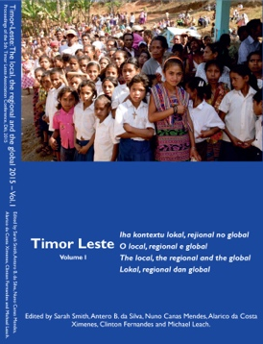
Card details Visa Mastercard
No. ..................................................................................................................
Expiry date......................................................................................................
Cardholder's name..........................................................................................
Signature........................................................................................................
Amount $A: ………………………………
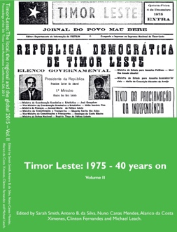
Mailing address
Name..........................................................................................................
Address.....................................................................................................
…………………………………………………………………………….
…………………………………………………………………………….
City................................ Postcode............... Country................................
Post to: Or email:
Bonita Wilder asshadmin@swin.edu.au
School of ASSH
Swinburne University of Technology
PO Box 218
Hawthorn, Victoria, AUSTRALIA 3122
Internal Use Only:
SUT Contact: ……………….…....…….. Ext: ……………..…… Mail No: ……….…….……

Item Code: …………………………….. Ledger: ……….….……… Debtor ID: ……….…....……
General Ledger Account:
1 | 1 | 2 | 7 | 3 | 6 | 3 | 0 | 7 | 1 | 0 | 6 | 5 | 4 | 0

Narration/Reference: Timor-Leste: the local, the regional and the global 2015 …… Receipt No: ………………….…

