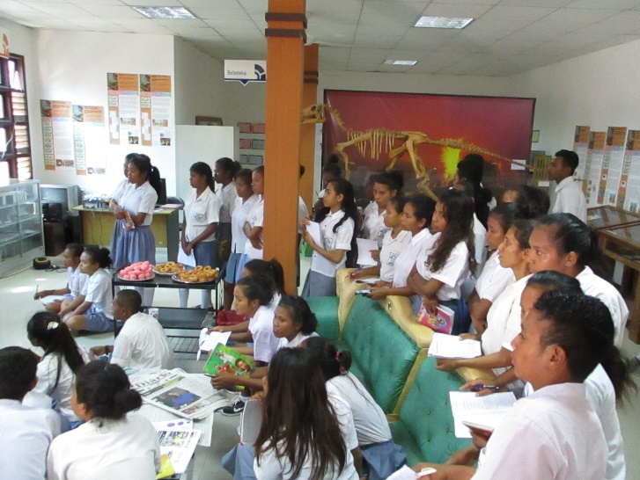
O Mundo Perdido Exhibit
Dili, Timor-Leste
Report, July 2018

The natural history exhibit ‘O Mundo Perdido’ in Dili, Timor-Leste is currently available for public viewing. The magnificent Tarbosaur skeleton stands to greet visitors in the main foyer of the Presidencial Palace, and the remainder of the pieces are part of the permanent ongoing display in the main function hall of Xanana Gusmao’s Reading Room, in Bidau. Two smaller satellite exhibits are open for interested viewers in Aileu and Baucau districts.
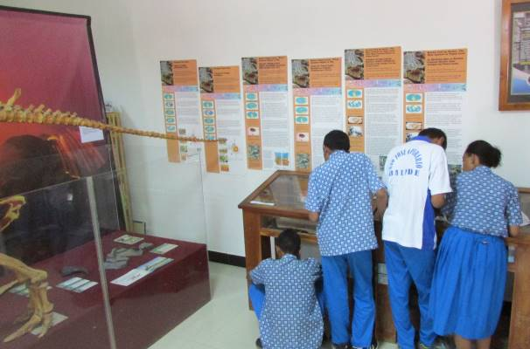The Timor-Leste National Commission for UNESCO has taken responsibility to oversee and maintain the exhibit, and has recently hired a new curator named Delfina Kastono. With a degree in mining and significant experience in Timor’s geology, Delfina’s primary interest is in education. Thus, she has been eagerly developing the educational programs of the exhibit, and receiving over 100 students per week to learn from the exhibit. In August with the start of the new trimester, she’ll ramp the numbers of weekly student visitors up to 130.
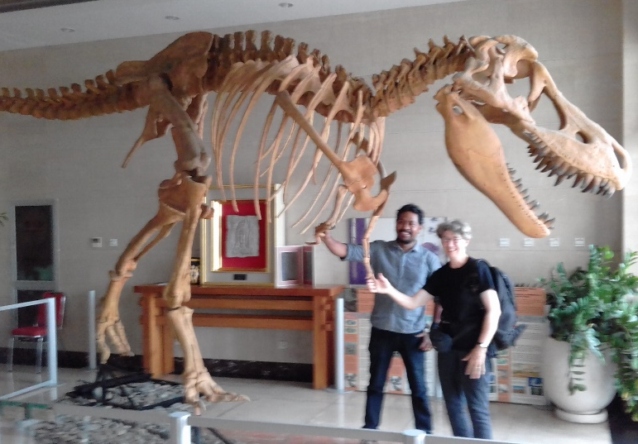
Visiting student groups arrive in minivans and spend around 2 hours viewing and learning from the exhibit items. For many, this is the first time they have seen actual fossils and representations of the long natural history of their home island. The skeletons and other fossils offer deep insight into how scientists have learned what we know about the distant geologic past. Teachers have also been keen to learn from the exhibit, especially senior high school geology teachers, few of whom have an adequate background for their current work.
Delfina is also developing hands-on activities that go hand-in-hand with the exhibit, so that younger students can really get their hands dirty and learn how fossils are formed by first uncovering and then preparing models of fossil shells. These activities link directly to the national science curriculum and give students deeper insight than any classroom experience.
Ongoing needs
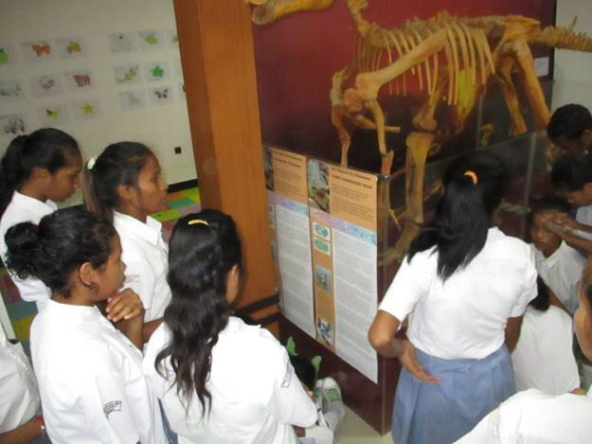The Timor-Leste National Commission for UNESCO is currently managing the exhibit on extremely limited funding from the Ministry of Education and small individual donors. Further funding is needed to increase access to exhibit for the students and public in the following areas:
- One half of Ms. Delfina’s salary, which has up to now been covered by an individual grant.
- Transport for students to visit the exhibit from nearby schools.
- Transport for Delfina to visit and support the satellite exhibits in Aileu and Baucau districts.
- Snacks and drinks for visiting classrooms.
- Materials for hands-on lessons for visiting students.
- Small stipends for university interns from biology and geology departments.
- Printing materials for distribution to visiting students and promotion at local venues.
Please contact us at tlnationalcom@gmail.com or Professor Patricia Rich pat.rich@monash.edu.

