HELPING TWO BLIND GIRLS IN SON LA DISTRICT
Kha A Cho and Kha A Di are the most unfortunate girls that I have ever met. I kept thinking about their lives, about their childhoods and what would come for their futures.
Born in darkness, the sisters have never seen any sunlight. They stay at home all day, eating whatever that is given, doing whatever instructed, if not, they sit in silence for hours. Sometimes I wonder if they ever wish for anything in life, but then again, there was nobody to teach them, to guide them into life, so this thought might’ve never even occurred to them. A Cho is 9 years old and A Di is 12 but they only know a little bit of H’mong ethnic language, just enough to understand their mother’s command: stand up, sit down..
Their father passed away 3 years ago during a drug fight with his brother. He used to be the breadwinner of the whole family, therefore, after his death, their family was in deep poverty. The children were sent to their father’s family in Hang Kia, Mai Chau, Hoa Binh province. Their mother got married to a Lao man, but afterwards, she was kicked out because of laziness, so she went back to bring the children to her hometown, in Long Luong, Son La province. Now, she does not take care of her children, but spends time flirting with her new boyfriend. The children are often left in starvation at home. She even suggested me to take the blind kids away so she didn’t have to worry about them anymore…
A group of volunteers from Photo.vn forum, including Lekima Hung and Le Bich, has extended their help to the family. They tried to bring Kha A Nha, the only son who is bright, to the local primary school, with the hope that the rest of the family can rely on him later. They also brought the two sisters to Hanoi for an eye test but failed because the doctor concluded there was only 1% chance of success. Recently, they have monthly supplied this family of five with rice, salt and dried fish.
Our group of travelers, including Hanh, Nguyen, Quang and myself have followed their movements and brought warm clothes to them last winter, and reminded their mother to take care of the children, because it seemed like it was a while since the last shower…
After a long time, we were trying to figure out a way to help the children, accidentally, through friends and colleagues, the children got admitted to the School of Education and Facilitation for Disadvantaged Children in Thai Nguyen Province. This was such good news for all who have been helping these kids, hoping for a bright future for them. I have visited the school and met with the Principal, Ms Pham Thi Lien, who said that the school was willing to admit the children from first to ninth grades, afterwards they could take part in vocational training, which is also available at the school. There are about 200 disadvantaged children and 50 teachers at the school now. New students will learn how to take care of themselves daily and after one year, they can speak Vietnamese language.
Ms Lien also informed me that the accommodation cost for both girls is 600,000 VND a month, the tuition fee is subsidized by the government. The girls also need to have complete documentation for admission on 20th August. We only have less than a month to change the girls’ lives. We need your help now!
Within one week, we have raised enough funds for half a year at the school for both girls, but in the long run, we’re going to need stronger support from the community to maintain their education financially. We plan to open a saving bank account and send the tuition fee monthly to the school, at the same time, having a trust fund for their future.
If you are interested in helping out, please contact us at:
Pham Minh Hoa
Email: hoap2b@gmail.com
Hand phone: 0125 355 3044
Bank account: Pham Minh Hoa - Vietcombank Ba Dinh District - 0611 001 649 796

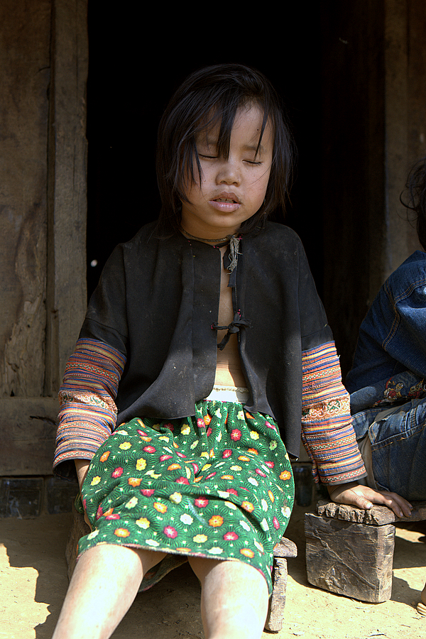
A Dì

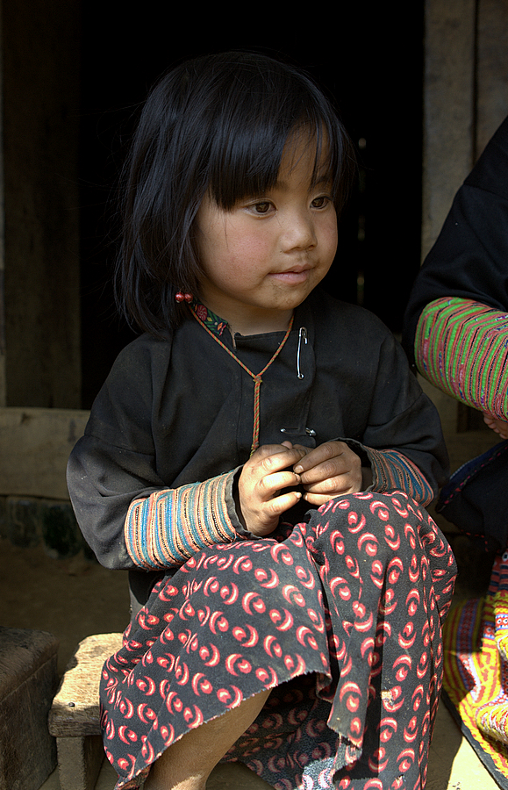
A Chô

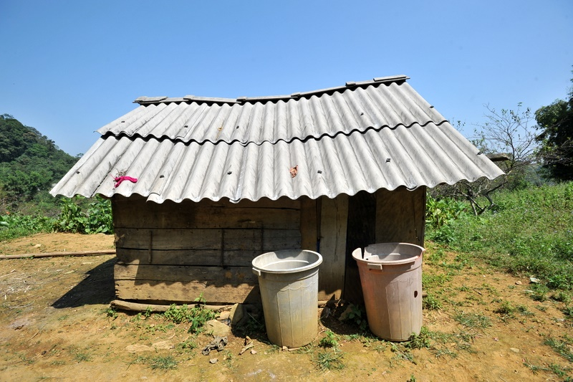
The temporary shelter this five-member family is currently living in.

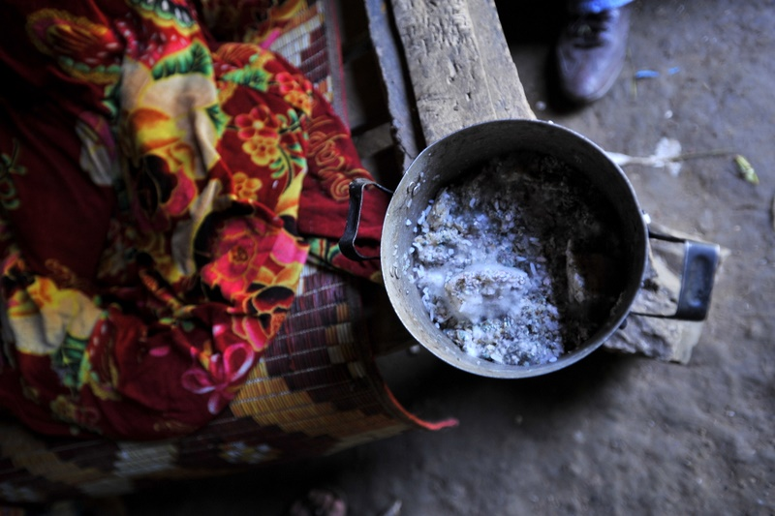
The children’s daily meal

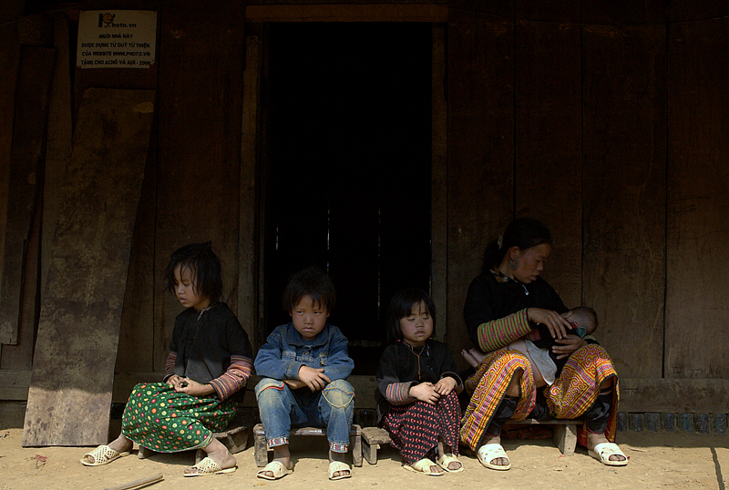
The five member family

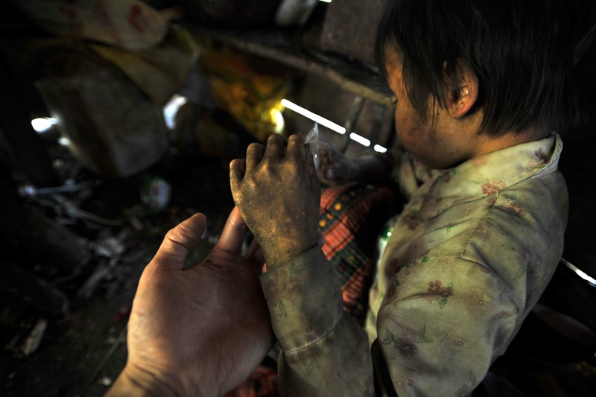
Helping hands are on the way for you girls

Photo courtersy: Lekima Hung and Photo.vn forum at:
http://www.photo.com.vn/Forums/viewtopic/t=9001/postdays=0/postorder=asc/start=15.html
http://www.matnauhoctro.com/4rum/showthread.php?t=296167

