ANU Press Publications on the Pacific 2014 - March 2016

Available free from http://press.anu.edu.au/ or as print on demand hardcopies at prices listed below

 | A Mission Divided  Race, Culture and Colonialism in Fiji’s Methodist Mission  By Dr Kirstie Close-Barry  ISBN 9781925022858 (Print version) $28.00 (GST inclusive)  ISBN 9781925022865 (Online)  Published December 2015
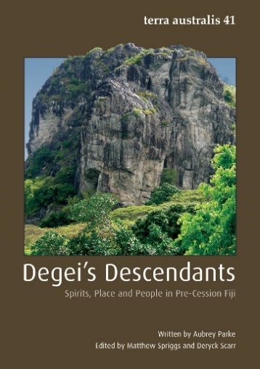 | Degei’s Descendants (Terra Australis 41)  Spirits, Place and People in Pre-Cession Fiji  Edited by Matthew Spriggs and Deryck Scarr  ISBN 9781925021813 (Print version) $55.00 (GST inclusive)  ISBN 9781925021844 (Online)  Published August 2014
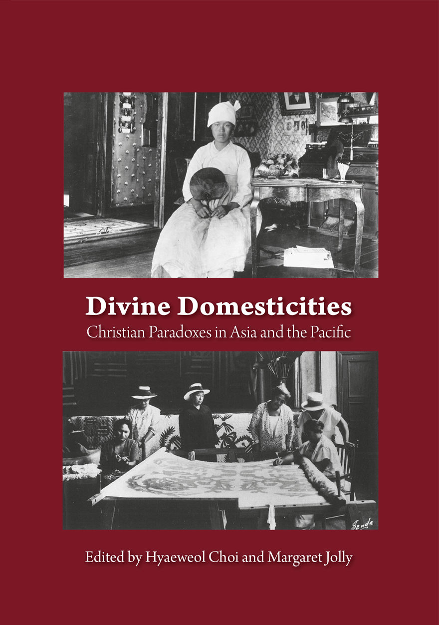 | Divine Domesticities  Christian Paradoxes in Asia and the Pacific  Edited by Hyaeweol Choi and Margaret Jolly  ISBN 9781925021943 (Print version) $35.00 (GST inclusive)  ISBN 9781925021950 (Online)  Published October 2014
 | Fiji: A Place Called Home  Daryl Tarte  ISBN 9781925022049 (Print version) $28.00 (GST inclusive)  ISBN 9781925022056 (Online)  Published November 2014
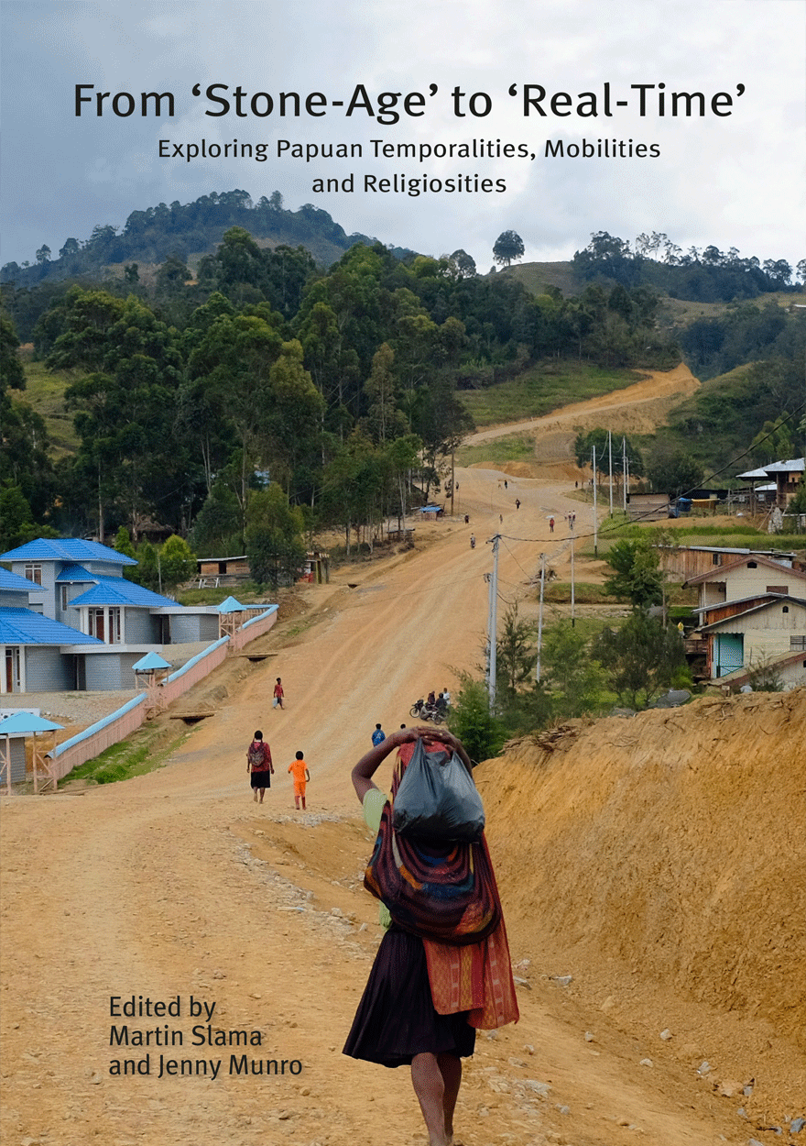 | From ‘Stone-Age’ to ‘Real-Time’  Exploring Papuan Temporalities, Mobilities and Religiosities  Edited by Martin Slama and Jenny Munro  ISBN 9781925022421 (Print version) $30.00 (GST inclusive)  ISBN 9781925022438 (Online)  Published April 2015
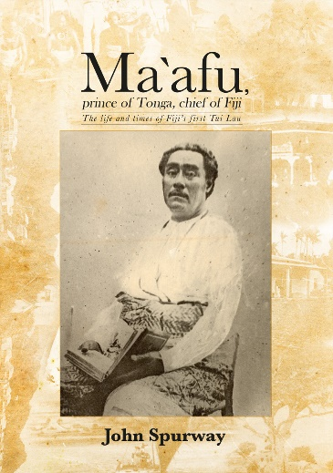 | Ma`afu, prince of Tonga, chief of Fiji  The life and times of Fiji’s first Tui Lau  John Spurway  ISBN 9781925021172 (Print version) $40.00 (GST inclusive)  ISBN 9781925021189 (Online)  Published February 2015
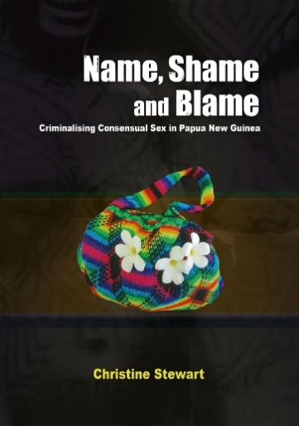 | Name, Shame and Blame  Criminalising Consensual Sex in Papua New Guinea  Christine Stewart  ISBN 9781925021219 (Print version) $33.00 (GST inclusive)  ISBN 9781925021226 (Online)  Published December 2014
 | Political Life Writing in the Pacific  Reflections on Practice  Edited by Jack Corbett and Brij V. Lal  ISBN 9781925022605 (Print version) $23.00 (GST inclusive)  ISBN 9781925022612 (Online)  Published July 2015
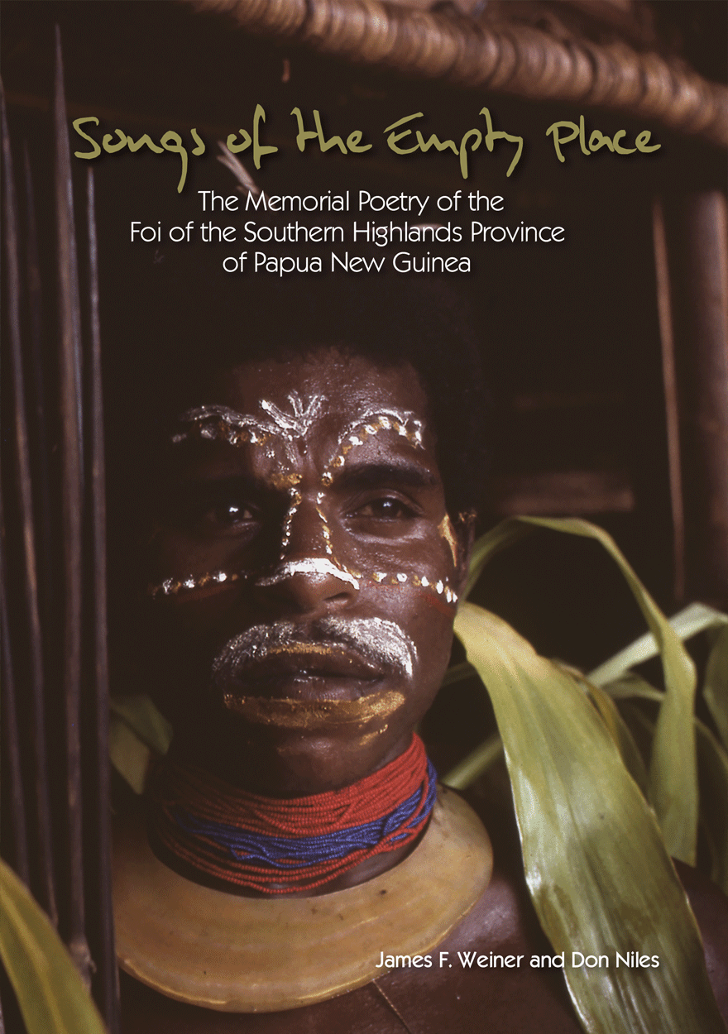 | Songs of the Empty Place  The Memorial Poetry of the Foi of the Southern Highlands Province of Papua New Guinea  By James F. Weiner and Don Niles  ISBN 9781925022223 (Print version) $28.00 (GST inclusive)  ISBN 9781925022230 (Online)  Published July 2015
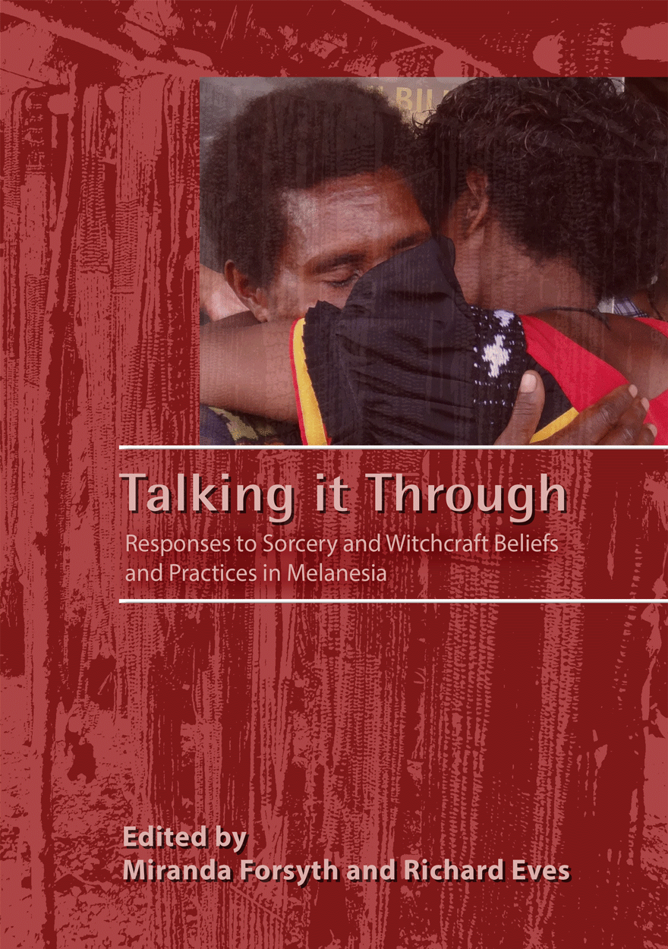 | Talking it Through  Responses to Sorcery and Witchcraft Beliefs and Practices in Melanesia  Miranda Forsyth and Richard Eves  ISBN 9781925021561 (Print version) $31.00 (GST inclusive)  ISBN 9781925021578 (Online)  Published May 2015
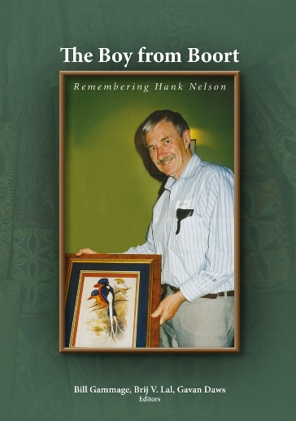 | The Boy from Boort  Remembering Hank Nelson  Edited by Bill Gammage, Brij V. Lal and Gavan Daws  ISBN 9781925021646 (Print version) $28.00 (GST inclusive)  ISBN 9781925021653 (Online)  Published July 2014
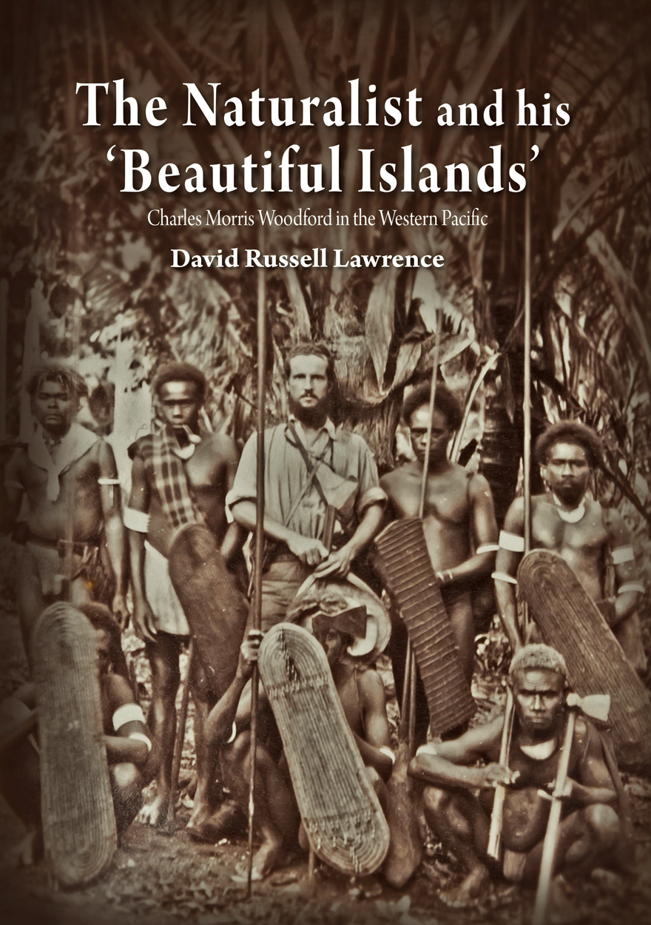 | The Naturalist and his ‘Beautiful Islands’  Charles Morris Woodford in the Western Pacific  David Russell Lawrence  ISBN 9781925022032 (Print version) $33.00 (GST inclusive)  ISBN 9781925022025 (Online)  Published October 2014
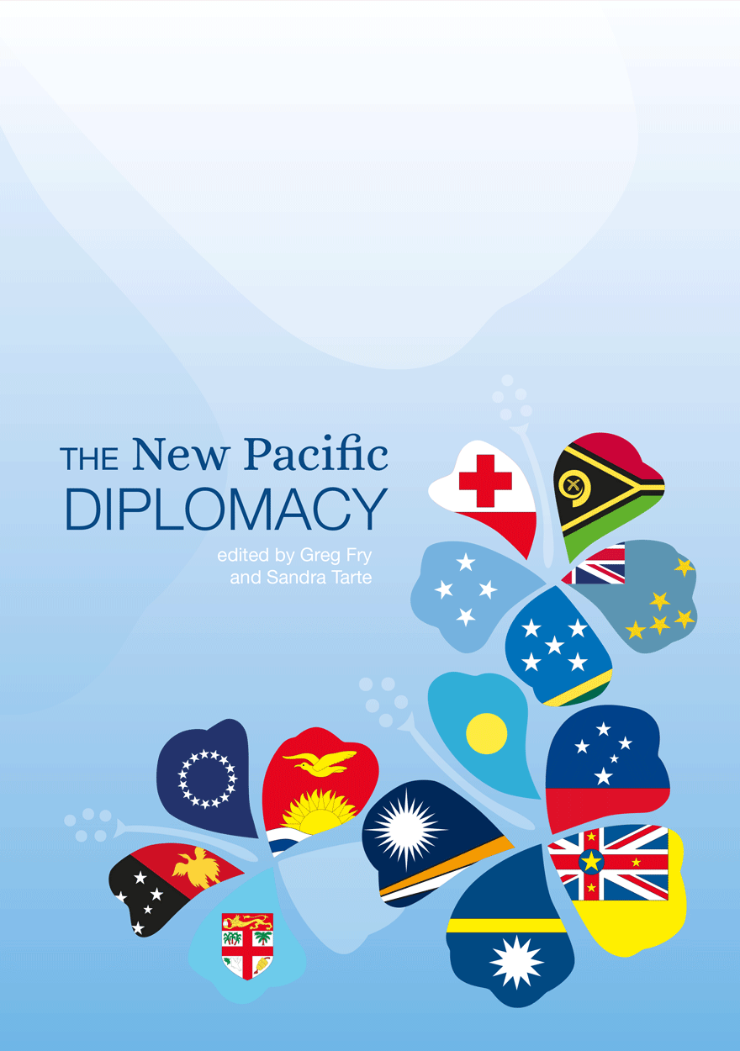 | The New Pacific Diplomacy  Edited by Greg Fry and Sandra Tarte  ISBN 9781925022810 (Print version) $33.00 (GST inclusive)  ISBN 9781925022827 (Online)  Published December 2015
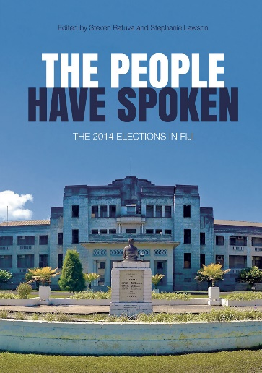 | The People Have Spoken  The 2014 Elections in Fiji  Edited by Steven Ratuva and Stephanie Lawson  ISBN 9781760460013 (Print version) $40.00 (GST inclusive)  ISBN 9781760460020 (Online)  Published March 2016
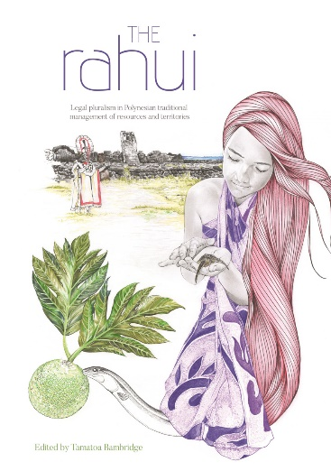 | The Rahui  Legal pluralism in Polynesian traditional management of resources and territories  Edited by Tamatoa Bambridge  ISBN 9781925022797 (Print version) $38.00 (GST inclusive)  ISBN 9781925022919 (Online)  Published March 2016
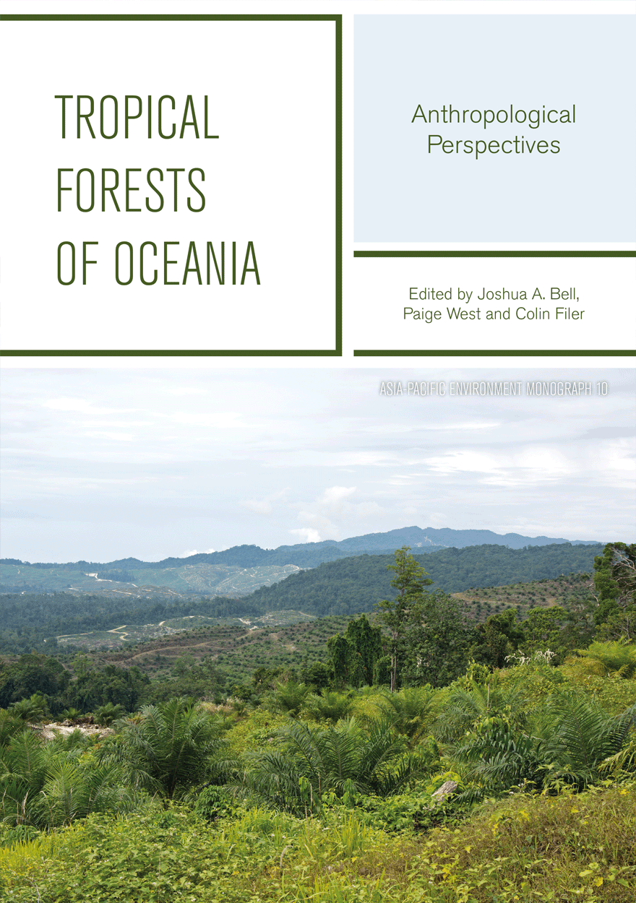 | Tropical Forests Of Oceania  Anthropological Perspectives  Edited by Joshua A. Bell, Paige West and Colin Filer  ISBN 9781925022728 (Print version) $30.00 (GST inclusive)  ISBN 9781925022735 (Online)  Published August 2015
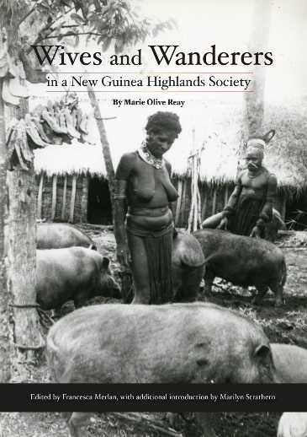 | Wives and Wanderers in a New Guinea Highlands Society  Women’s lives in the Waghi Valley  Marie Olive Reay  ISBN 9781925022155 (Print version) $28.00 (GST inclusive)  ISBN 9781925022162 (Online)  Published December 2014  Edited by Francesca Merlan, with additional introduction by Marilyn Strathern

