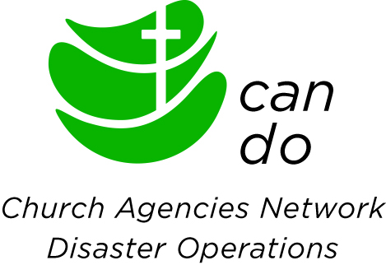

**Manager, CAN DO Coordination Unit**

* Leadership Humanitarian Role
* Consortium of Church Agencies Network Disaster Operations

Caritas Australia is the Catholic agency for international humanitarian relief and development in Australia. Through effective relationships with the Church, partners and communities in Africa, Asia, Latin America, the Pacific and Australia, Caritas Australia helps to end poverty, promote justice and uphold dignity. Our programs promote the good of every person and of the whole person, regardless of people’s religious, political or cultural beliefs. We envisage a world in which children, women and men most vulnerable to extreme poverty and injustice are agents of their own change and architects of their own development.

Church Agencies Network Disaster Operations (CAN DO) is a consortium of eightAustralian based humanitarian church agencies that exists to build the resilience of communities with whom the agencies work, to strengthen the capacity of partner organisations, and to enhance agencies’ effectiveness in responding to disasters, especially in the Pacific region.

#### This role, based from the Caritas Australia head office in Sydney, will direct the CAN DO Coordination Unit and oversee all of its functions including coordinating humanitarian preparedness, response, disaster risk reduction and capacity building initiatives with local partners. The Manager will be the lead representative. The partnership and will have day-to-day line management of up to two staff. The Manager reports internally to the CA Humanitarian Manager, is guided by the CANDO Steering Committee, and works in close coordination with Consortium members.

To be successful in this role you must be able to demonstrate the following selection criteria:

* Tertiary qualifications in international development or other relevant discipline.
* Over five years’ experience in senior leadership roles within the humanitarian sector, preferably with faith based organisations.
* Substantial demonstrable experience in the field of DRR/DRM and humanitarian response, particularly in the Pacific region including a sound knowledge of humanitarian standards and codes.
* Strong leadership abilities and experience in a role managing multiple partners and programs in multiple countries preferably with or through local church organisations.
* Demonstrated ability to implement projects with rigorous deliverables and timelines in accordance with set timeframes and donor regulations while maintaining high quality and with multiple implementing partners.
* Proven ability in collaborating closely with multi-level stakeholders, including churches, government, donors, and implementing partners with a sensitivity to cultural differences.
* Proven sound judgement and decision-making skills.
* Demonstrated track record of designing, managing and reporting on large and complex grants.
* Evidence of experience in capacity building and mentoring of local organisations, especially small and emergent organisations.
* Highly developed verbal and written communication skills including demonstrated experience in cross cultural communication, negotiation, public speaking, media engagement, mediation, and diplomatic skills.
* Excellent computer skills in a Microsoft Windows and Office environment including Word and Excel.
* Ability to travel domestically and internationally on a regular basis with capacity to be deployable on short notice where required.
* An understanding of and willingness to work within the Christian ethos.
* Eligible to live and work in Australia.

To apply for this exciting opportunity visit [www.caritas.org.au/jobs](http://www.caritas.org.au/jobs) to view the full Position Description and send your application to [jobs@caritas.org.au](mailto:jobs@caritas.org.au) by **Monday, 5pm, AEST, 21 November 2016.** Applications must specify residency or work visa status, include a CV and a cover letter which addresses the Selection Criteria indicated in the referred Position Description.

Caritas Australia recognises the personal dignity and rights of children towards whom it has a special responsibility and duty of care and respect. The successful candidate will be required to undergo a National Criminal History Record Check.

Caritas Australia is an Equal Employment Opportunity (EEO) employer and welcomes and encourages Aboriginal and Torres Strait Islander applicants for all advertised positions.