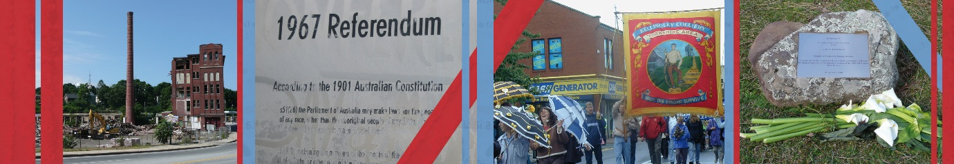
Centre for Heritage and Museum Studies, ANU
Friday Seminar Series:

2 December 2016

Māori, Art History and Museum Studies in the 21st century

By Ngarino Ellis

Abstract: In a climate of New Art History, and New Museology, what does it mean to undertake research into Indigenous art and culture today? What are some of the challenges that need to be addressed? What kinds of conversations need to be articulated? And what does it all mean? This talk will engage with some of these complexities through a discussion of recent and current teaching and research projects. These prioritise working collaboratively across tribes (rather than across cultures), in a way which aims to stimulate important and ongoing discussions in courses, museums, art galleries and other spaces. Significantly, the voices of Indigenous writers, curators, and artists are presented as being the first voice that must be heard and read, rather than mediated through others. This has the potential to transform the writing of and understandings of art histories and Museum Studies on a global scale. Tihei mauriora!

Dr Ngarino Ellis (Ngāpuhi, Ngati Porou) is a Senior Lecturer in Art History, and Co-ordinator of the Museums and Cultural Heritage Programme at the University of Auckland. She lectures on Indigenous women’s art, Art Crime, Māori art history, and Museum Studies. She has published widely on many facets of Māori art, most recently A Whakapapa of Tradition: One Hundred Years of Ngati Porou Carving, 1830-1930 (2016) with Natalie Robertson (Ngati Porou) which explores the transformation of carved structures in her tribal area. Together with Deidre Brown and Jonathan Mane-Wheoki (both Ngāpuhi), she is currently writing a new book, entitled Toi Te Mana. A History of Indigenous Art in Aotearoa New Zealand which explores, problematises and celebrates art history from Indigenous perspectives. Other projects since 2013 include Indigenous biography, moko signatures, colonial artist Gottfried Lindauer and a collaborative project on Māori personal adornment.

The conversation kicks off at 4.00 in the Sir Roland Wilson Theatrette (Building #120) at ANU, followed by drinks at 5.30 at University House

