http://www.theaustralian.com.au/arts/visual-arts/shared-history-in-the-frame-for-png-artists/news-story/1e8839ad56d283cbfbe3ea4269b3ed56
Weekend Australian 12 Oct 2016 Visual Arts

Shared history in the frame for PNG artists
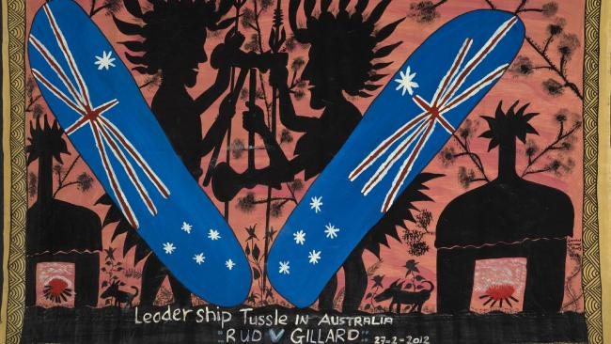
Leadership Tussle in Australia: RUD V GILLARD 27.2.2012 by Simon Gende. Picture: Gallery of Modern Art Foundation
- Ruth Mcdougall
- The Australian
- 12:00AM October 12, 2016
In March 2012, Papua New Guinea artist Simon Gende, faced with a blank canvas, chose to adorn the surface with the silhouette of male and female figures wearing spectacular headdresses engaged in battle against a blood-red sky.
The figures — behind shields emblazoned with the Australian flag — were identified in the work’s title, Leadership Tussle in Australia RUD V GILLARD 27.2.2012, as Australian prime minister Kevin Rudd and his successor Julia Gillard. The painting documents the second of three leadership battles between Rudd and Gillard. In Gende’s painting, Gillard stands somewhat defensively, feathers bristling, in front of the big house.
With its peculiarly Papua New Guinean honesty and humour, Gende’s painting may be confronting for Australians who, often at the expense of their Pacific neighbours, pride themselves on the sophistication of their democracy. What is particularly striking about this work, though, is that it articulates the high level of engagement in PNG with Australia and its contemporary history.
Painted when Michael Somare and Peter O’Neill, PNG’s former and incumbent prime ministers, were themselves locked in a leadership battle, the work speaks eloquently of the legacy of the Westminster system of governance, bequeathed by Australia, in its former protectorate.
Gende’s painting also expresses a desire to engage Australians, through a reflection of shared and parallel histories, challenges and aspirations, in a conversation about the future.
How many Australians, though, possess the knowledge to adequately respond? Journalist Sean Dorney recently reflected on PNG’s 40th anniversary of independence: “At around half a billion dollars a year, Australia gives more aid to PNG than to any other country — yet Australians seem to know little or care less about the country … How many Australians realise that PNG was once an Australian colony?”
That is precisely the kind of question that provides a framework for the exhibition No 1 Neighbour: Art in Papua New Guinea 1966-2016. The exhibition does not aim to provide a comprehensive overview of art created in PNG in the past half-century. Rather, it seeks to introduce Australian audiences to artworks that expand our knowledge of a shared history. It also helps to develop a more nuanced understanding of the dynamic contemporary culture of our nearest neighbour.
Australia’s governance of Papua (1906-75) and the mandated territory of New Guinea (1921-75) is often characterised as an era of extraordinary cultural and economic change, during which areas isolated from the wider world were opened up to external influences. Longstanding traditions of tribal tensions and warfare were calmed, Christianity took hold and large-scale agriculture was introduced. Numerous Australians participated in these events and the accompanying changes as administrators, kiaps (patrol officers), nurses, teachers, artists, soldiers, agriculturalists, collectors and missionaries.
Their contributions — both positive and negative — continue to be acknowledged by artists in works such as the dramatic Baining kavat (mask) with the Australian coat of arms on its forehead, and the Abelam kiap sculpture. They are also evident in Gende’s painting No 1 Kiap blong Australia Mr Jim Taylor l brukim bush long Highlands Papua Niugini (1999), documenting the celebrated Australian patrol officer Jim Taylor’s eventful walks in the 1930s, which opened the previously unexplored Western Highlands province to change.
Many Australians have travelled home with artefacts, narratives, images and memories from PNG. Others stayed or returned repeatedly, inspired by the culture and passionately committed to a profession of providing service or to maintaining relationships.
Of course, Papua New Guineans themselves have reflected on the colonial period of their history. As poet Lynda Thomas observed in 1971, although social, economic and political development was the aim of the Australian administration, many Papua New Guineans experienced this as oppression:
The master is like a mountain
the higher it gets, the colder.
But master, we are the rocks beneath
on which you stand. Without us
You are no longer a mountain
How long shall we carry your weight?
During the period of the Australian administration and trusteeship, Papua New Guineans not only began to imagine themselves in relation to a vastly expanded world but they responded to opportunities to advance conversations and relationships, and agitated for greater control over their own affairs.
Koivi-Aua (Tommy Kabu) from the Purari Delta, for example, led a nationalistic movement of New Men intent on transforming the traditional Hiri trade of sago for pots between the Gulf people and the Motuans into a kompani (company) based on monetary exchange.
In Australia, discussions about PNG’s history of independence are often dominated by accounts of its failings. But although it continues to face challenges, there is also much reason for hope. During the nation’s 41 years of independence, a strong constitution and judicial system, and respect for parliamentary democracy, have meant avoiding the military coups that mar the history of other developing countries.
As Dorney observed recently, one of PNG’s greatest attributes is the freedom afforded to the press, the judiciary and the population at large to address the country’s problems. PNG artists participate fully in such dialogues, providing often unflinching perspectives of their time and place.
In the period leading up to and following independence in 1975, the country’s cultural producers played a key role in shaping and articulating the nation’s image and history.
Artists Timothy Akis, Mathias Kauage and Jakupa Ako began to exhibit works reflecting the influence of new urban lifestyles and technology around this time. Playwrights Nora Vagi Brash and John Kasaipwalova created plays that toured to villages across PNG, examining the legacy of the Australian administration and questioning the country’s sociopolitical direction.
Writers Vincent Serei Eri, Rabbie Namaliu, Albert Maori Kiki and Bernard Narokobi, after publishing some of PNG’s first novels, literary essays and philosophical propositions, went on to become its political leaders.
It was also during this period that the country’s creative producers found an international voice, with many exhibiting and performing on the global stage.
The popular arena cultural shows introduced by Australian administrators in the early to mid-20th century were part of a project of nation-building showcasing Melanesian culture and spirituality to new audiences.
Musicians celebrated the richness of traditional instruments and song, transforming them with new rhythms. And the humble string bag, or bilum, moved beyond its traditional locales and uses to incorporate designs based on symbols of national identity, such as the PNG flag; it was then worn and recognised in urban centres throughout the world.
Not all change has been viewed positively. In 2000, author Regis Stella, writing about the new millennium, lamented the local production of images of PNG culture for consumption by tourists, arguing that it led to the “commodification of culture and, indeed, national identity”.
It is true that the production of symbols of culture for sale has contributed to the exoticisation of people and place. However, many artists engage with the market and tourism in complex ways.
In fact, with limited infrastructure for the sale of art, even the most successful Papua New Guinean artists, such as Kauage and Martin Morububuna, have used markets and festivals to sell their work and support their practice.
Ruth McDougall is the curator of No 1 Neighbour: Art in Papua New Guinea 1966-2016. This is an edited extract of her catalogue essay for the show, which runs from Saturday to January 29 at the Queensland Art Gallery, Brisbane

GOMA website: https://www.qagoma.qld.gov.au/whats-on/exhibitions/no1-neighbour

