Asia Pacific Broadcasting - Distribution Options

# Objective of this document

Provide an overview of content distribution options for reaching the Asia Pacific region in the light of recent technological changes.

**Objective of this document** **1**

**The author** **1**

**Background** **1**

**Shortwave AM broadcast** **2**

**Shortwave DRM broadcast** **3**

**Satellite direct** **5**

**Local FM** **5**

**Podcast** **6**

**Internet streaming** **7**

New LEO options 7

**Program supply** **8**

**Conclusion** **8**

# The author

Peter Marks has a broad experience in media including roles at ABC, News Interactive and CNN. Peter has technical knowledge, a software developer who worked on projects such as ABC iview, and he holds a BOCP (was required to perform technical work on broadcast transmitters). Peter also has a long history of explaining technology, for over a decade he was technology editor on Radio National Breakfast.

# Background

In the last decade, there have been significant changes in the media landscape both globally and also in the Asia Pacific region.

The changes have been driven both by technology, such as the rise of smartphones since 2007, and the widespread availability of wireless data networks.

While developing countries [lag in smartphone ownership](http://s1.pulso.cl/wp-content/uploads/2016/02/2258581.pdf)[1] compared to advanced economies, ownership is rising strongly and lower cost devices running [Android One](https://en.wikipedia.org/wiki/Android_One)[2] will further reduce the gap.

Smartphone shipments appear to have [plateaued](https://www.recode.net/2018/5/30/17385116/mary-meeker-slides-internet-trends-code-conference-2018)[3] in developed countries and this has led to the focus on making devices affordable in developing countries.

Factors that should be considered when deciding on appropriate technical distribution options include:

* Cost to users to listen and watch
* Cost to the broadcaster
* Robustness in the face of extreme weather such as cyclones
* Ease of local disruption by those who wish to silence outside reporting

# Shortwave AM broadcast

AM on shortwave has great advantages including long range and low cost receivers. Because shortwave transmission can originate far from the listener it is robust in the face of extreme weather, natural disaster and local censorship.

A single shortwave transmitter can cover thousands of kilometers.

While shortwave can be jammed by a wealthy power, this is rarely 100% effective.

Because shortwave broadcasting has been around for many decades there are receivers throughout the community. Counter-intuitively, in this era of smartphones, there appears to be a boom in production of new models of receivers from manufacturers including [Tecsun](https://www.tecsunradios.com.au/), [Sangean](http://www.sangean.com/products/product_category.asp?cid=10) and others.

Despite the reduction in shortwave broadcasts in recent years there is still a significant amount of airtime [available](http://www.drm.org/wp-content/uploads/2017/02/HFCC-DRMstat2016-04-14-2.pdf)[4] via this platform. A glance at a shortwave band in the early evening shows enough activity to interest listeners.

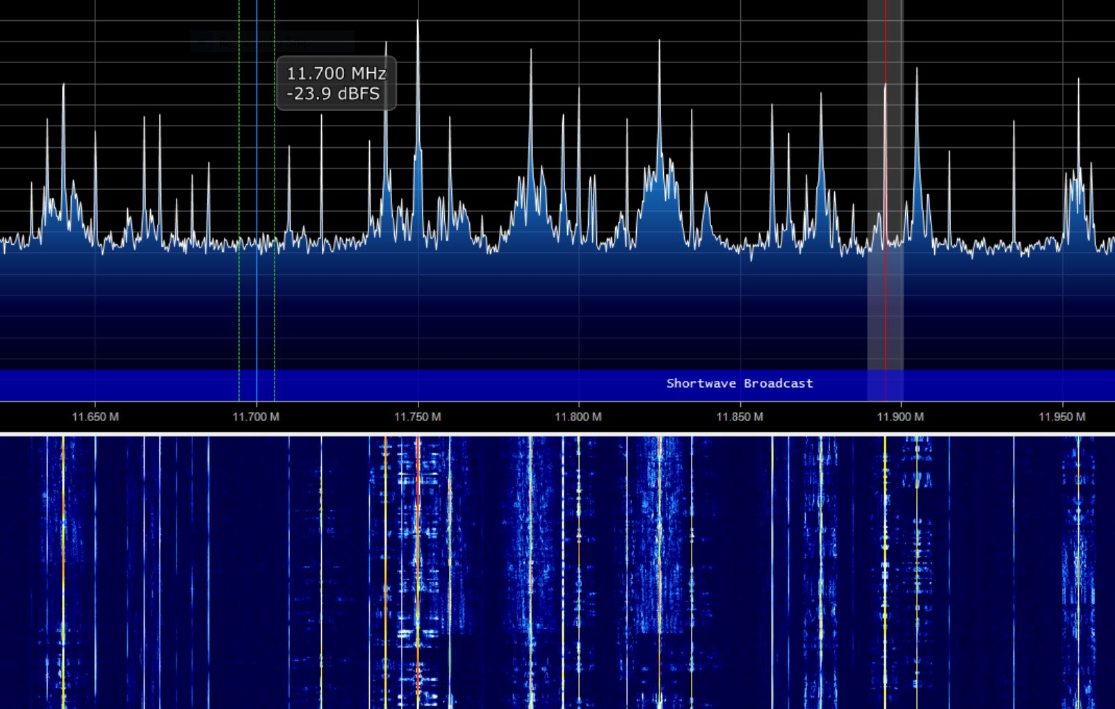

China has significantly [ramped up](http://money.cnn.com/2018/03/21/media/voice-of-china-propaganda-broadcaster/index.html) their investment in broadcasting in recent years.

China Radio International uses channels that were former ABC Radio Australia (RA) frequencies.

17840 kHz, 15425 kHz, 12085 kHz, and 9580 kHz were used by Radio Australia and are now used by China Radio International at powers from 100KW to 500KW.

Modern shortwave radios are much easier to use, with digital frequency entry and display, and perform better than sets in the past. Many modern radios can are rechargeable and can be charged from the same sources as mobile phones including small solar chargers.

The transmitter sites and equipment previously used by Radio Australia have been disposed of and new sites, or time rental arrangements will be needed.

An incidental benefit of shortware is that it can be received in the Australian outback.

Costs scale with broadcast duration.

# Shortwave DRM broadcast

[Digital Radio Mondiale](http://www.drm.org/) (DRM) has the potential to deliver FM quality audio plus useful metadata and text over long distances. It does this by leveraging modern digital modem and audio compression technology, carried over shortwave radio.

As with AM shortwave a single transmitter can cover a region of thousands of kilometers.

India has aggressively rolled out a network of local medium wave and some shortwave DRM broadcasts. It is possible to simulcast both analog and digital modes on the same transmitter and India does this in many cases.

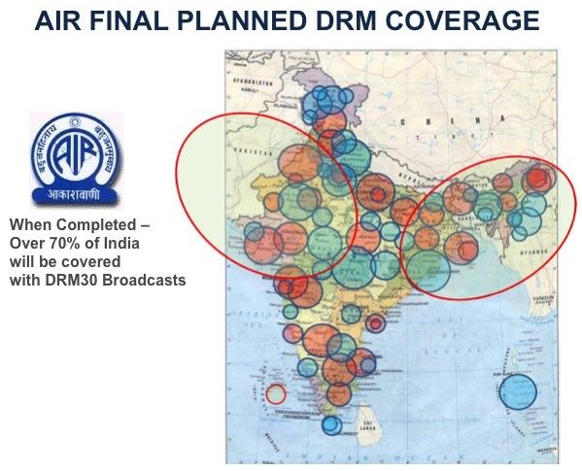

In our region, DRM [broadcasts](http://www.drm.org/wp-content/uploads/2018/06/SCHEDULES-OF-DRM-BROADCASTS-WORLDWIDE-A18-5.pdf) are:

* China National Radio (to NE Asia)
* Radio Romania International (to China)
* BBC World Service (to India)
* Radio Kuwait (to India)
* Radio New Zealand International (to Pacific Islands)

DRM is good as a satellite replacement for local distribution and is much more available and cheaper than satellite Single Channel Per Carrier (SCPC).

So, despite the current lack of receivers a DRM transmission could be used to feed local FM relays and when receivers become available they could be used to receive directly thus mitigating the drawback of local political interference.

An incidental benefit of DRM shortware is that it can be received in the Australian outback by listeners motivated enough to purchase a receiver.

Costs scale per broadcast. It would be cheaper to have our own dedicated transmission than to rent transmit capabilities if ramped up. If DRM receivers were to be supplied then this would scale by listener.

DRM receivers have not taken off in the market so far. The World Radio and TV Handbook, in it’s 2008 review, commented that although 10% of shortwave radios are replaced every year, consumers won’t spend more for a DRM receiver unless there is unique content available on it.

The adoption and promotion of DRM by Australia will help this technology to get more of a foothold.

# Satellite direct

There are readily available consumer receiver boxes for satellite TV and radio channels can be added on.

The [Lyngsat](https://www.lyngsat.com/) site has list of available satellite channels. (Note that it’s interesting to see how much CRI and CCTV have expanded in recent years. There are 15-20 CRI channels targeted at the Pacific).

Reception of satellite TV has lost popularity in recent years as increasingly all content is available via the internet.

Radio Australia used to be carried on PAS-2 and PAS-8 but that was five years ago and things will have changed[5].

Note that C band, while cheaper, is badly affected by rain whereas Ku band is not. Radio Australia was previously on C band. The C band dishes are also larger, at about 3m diameter and are frequently damaged by cyclones.

Costs scale per transponder / footprint.

# Local FM

An excellent way to reach local listeners due to good signal strength and widespread access to FM receivers. Many Android phones include an FM receiver feature.

FM can be received up to 65 km from the tower but the signal is obstructed by mountains so it is difficult in countries such as PNG, Solomon Islands. FM is a perfect technology for town centres and heavily populated rural areas. Low power, short range FM transmitters are very cheap and modern remote monitoring systems make them much cheaper to maintain than in past effors.

A drawback of this approach is that local transmitters are vulnerable to extreme weather, natural disaster and local censorship.

Program feeds have traditionally been via satellite downlink but others including [RNZI](https://www.radionz.co.nz/international/pacific-news/323555/rnzi-remains-essential-voice-of-the-pacific) are using DRM over shortwave to distribute content[6].

To enable this in the past ABC would:

* Buy equipment, possibly shared
* Install dish, receiver
* Maintain
* Power bills

2010 - 2013 “heyday” for this[7], there were about 30 sites at peak 3 in Cambodia, 2 in PNG, 2 in Solomons, 1 in Vila, 2 in Fiji, Samoa, Cook Islands, which played RA English and local language as available.

Radio Australia used to have two full time staff to maintain the network as there was little local capability for maintenance or fault finding.

Mistakes were made that limit the audience for our FM relays. Nearly all of its FM transmitters in the Pacific are on frequencies 100 Mhz or above, however nearly all motor vehicles in the Pacific Islands are 2nd Hand Japanese - whose radios only cover 76 - 90 MHz. So no car, bus, taxi was able to hear the ABC broadcasts.

The ABC transmitters are so low powered that people with mobile phones with built in FM receives say the signal is too poor to be usable.

Costs scale per site but are fixed after that.

# Podcast

The internet connected smartphone is ubiquitous in developed nations and has become the primary way for people to get news and communicate. Podcasts are still an emerging media but correlating with smartphone adoption, consumption is rising sharply.

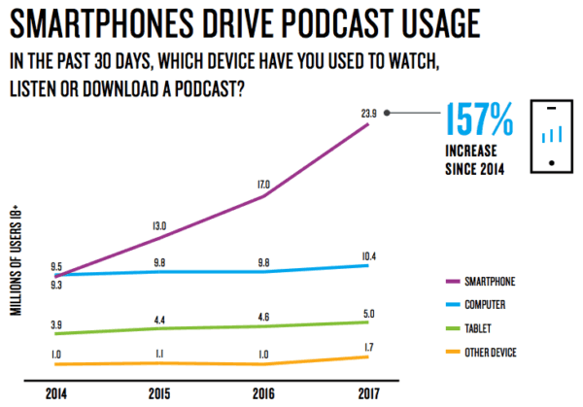

Graph from Nielsen Q1 2018 Podcast Insights showing US data.

In developing nations, particularly those with rugged terrain, mobile networks are still to be rolled out and there are many communities that will not have a network for many years.

Where there is mobile data and smartphones, podcasts as a media platform have a number of advantages in the Asia Pacific region:

* They can be delivered over slow internet connections due to their asynchronous download delivery nature.
* Listeners “stick” because of the RSS based subscription system.
* Metrics are [available](https://help.apple.com/itc/podcastsanalytics/#/itc623752a8d) for some clients giving insights into how much of each program listeners use and what they skip.
* Listeners are not restricted to “appointment” listening but can choose when they listen and resume later

Internet distributed podcasts are vulnerable to local political censorship.

Costs scale linearly by listener do to file hosting.

# Internet streaming

Looking to the future, (decades out), high speed internet will be available everywhere at a low enough cost that the price will have as little conscious impact as the consideration we now give to turning on a light.

Streaming does require a reliable internet connection during the stream. Unlike podcasts which can download over a slow or unreliable link, live streaming needs a fairly consistent speed of connection while listening.

The developed countries the digital music business has already [transitioned](https://www.statista.com/statistics/669113/number-music-streaming-subscribers/) from a model where music is purchased to where consumers pay to stream their music via services such as Spotify, Apple Music, Amazon, Pandora and others.

A problem for streaming broadcasters, that has been largely solved by music streaming services, is discovery. The [list](https://en.wikipedia.org/wiki/List_of_Internet_radio_stations) of streaming radio stations is large and often listeners find them via promotion on traditional radio.

The days when all media will be distributed over the internet are [not too far away](http://www.bbc.co.uk/mediacentre/speeches/2018/matthew-postgate)[8].

Local internet services are vulnerable to local political censorship and disruption in times of extreme weather.

## New LEO options

Mobile internet data costs are slowly falling, or rather the amount of data is going up for a similar cost but it’s possible that new [low earth satellite networks](https://www.theverge.com/2018/3/29/17178126/spacex-satellite-broadband-internet-fcc-approval-license-starlink-spectrum) specifically launched for providing internet access will disrupt current internet provision in the years ahead. These systems have [major backing](http://time.com/4638470/spacex-internet-elon-musk/) including [Elon Musk](https://www.cnet.com/news/how-spacex-brings-starlink-broadband-satellite-internet-to-low-earth-orbit/), Richard Branson and Bill Gates.

The significance of low earth orbit satellite data networks is that future pocketable devices may be able to access them directly and technology has been developed to ensure high speed and [low latency](https://www.isoc.org/inet96/proceedings/g1/g1_3.htm). The price of delivering internet is dominated by the laying of cable and hooking up of home so direct from satellite may end up being the cheapest option.

The SpaceX system proposes 10,000 satellites at about 340 km in altitude "enabling the provision of high speed, high bandwidth, low latency broadband services that are truly competitive with terrestrial alternatives."

Google has [Project Loon](https://x.company/loon/) which uses a network of balloons designed to extend internet connectivity to people in rural and remote areas worldwide. Loon has been tested and provided internet connections from balloons at 100 km altitude at 10 Mbps directly to LTE phones on the ground.

Streaming costs scale per listener.

# Program supply

An option is to produce programs and have local partners insert them into their schedule for local broadcast.

In the end, compelling, trusted content will earn the devotion of listeners and a successful model used by the [PRX](https://www.prx.org/) network, which includes popular programs including “This American Life”, “The Moth”, and the Radiotopia network, is to provide programs for air though partners.

PRX also trains producers and develops technology. They claim a reach of 25 million people in the US.

Working with local broadcasters, providing regular programs that fit in with their daily schedule would save the expense of running our own broadcast network.

Drawbacks include the lack of assurance that the supplied programs won’t be altered, broadcast at unappealing times or simply taken off due to local political pressure.

# Conclusion

We are in a time of technology change and it’s likely the Asia Pacific population will follow a similar path to developed nations.

A multi-prong approach seems wise with some sort of locally available broadcast that actively promotes deeper engagement via podcasts.

Peter Marks with input from Nigel Holmes.

Peter is a software developer, technology commentator and holds a BOCP.

Nigel was the Transmission Manager at Radio Australia.

1. Pew Research Center, February, 2016, “Smartphone Ownership and Internet Usage Continues to Climb in Emerging Economies”
2. <https://www.android.com/intl/en_au/one/>
3. Mary Meeker’s Internet Trends report 2018 published by Kleiner Perkins Caufield & Byers at the Code Conference
4. HFCC HF (Shortwave) Radio Broadcasts in A16 (Summer 2016) (Also shows DRM)
5. Greg Whitten at ABC can expand on this.
6. Adrian Sainsbury at RNZI can advise on this.
7. Check ABC Annual reports for more details.
8. Chief Technology and Product Office, BBC in a speech to the DTG Annual Summit in London on Thursday 10 May, 2018