CHL History Seminar

Basham Room, Baldessin Precinct Building (#110)

Friday 3 May, 1-3pm

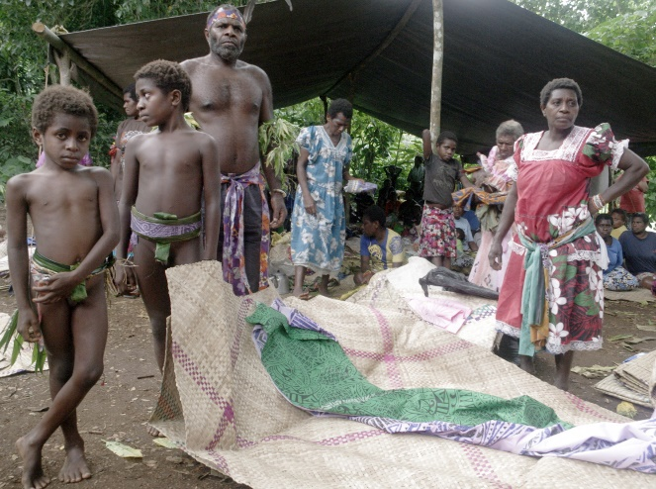

**Speaker:**

Paul Mitchell

**Title:**

Nemasien: Mbwotegot Cosmology in Transition (final thesis presentation)

**Abstract:**

This thesis explores the ways in which Oceanic Theology has influenced the Mbwotegot of south central Malekula in their recent adoption of Christianity, to contextualise the cultural knowledge that underpins socio-political regeneration and projection. The Mbwotegot-speaking peoples inhabit the rugged interior of south Malekula in Vanuatu, an area still without infrastructure such as roads, airstrips and permanent settlements. Due to the difficulties of their terrain, the Mbwotegot were largely ignored by administrators, planters and missionaries during the colonial era. For many years, Mbwotegot disdained Christianity, until their collective conversion during the 1980s, just prior to the Presbyterian adoption of ‘gospel and culture’ pedagogy in Vanuatu. Informed by the rising influence of Oceanic Theology, ‘gospel and culture’ privileges indigenous contextualisation. This framework has enabled Christian Mbwotegot to retain significant pre-Christian cosmological understanding and ceremonial practice, including the *nalawan* ceremonial cycle and the *nemasien* funerary practiceswhich close off that cycle.

The major colonial-era impact on Mbwotegot was severe depopulation, creating for them an ongoing susceptibility to a globally driven development ‘frontier’ in their lands. This thesis argues that the Mbwotegot *nalawan* and in particular the *nemasien* funerary practices, publicly re-assert the associations of lineage with place, and re-affirm a network of allied support for that assertion. This thesis further argues that these ‘geographies of power’ are not only important in maintaining stable land tenure relations as Mbwotegot numbers rise, but are also a local expression of global frontier-making practices, offering a potential foundation for Mbwotegot ‘conjuring of scale’ to counter the cultural erasure upon which frontiers are projected.