Pacific and Asian History Seminar

1-3pm, Friday 26 July 2019, Tardis Room (E2.02), Baldessin Precinct Building (110)

**The Spirit of Mining and the Desire to be Globally Present:**

**New Caledonian Perspectives**

Marta Gentilucci

PhD student, Department of Cultural and Social Anthropology, University of Milano-Bicocca

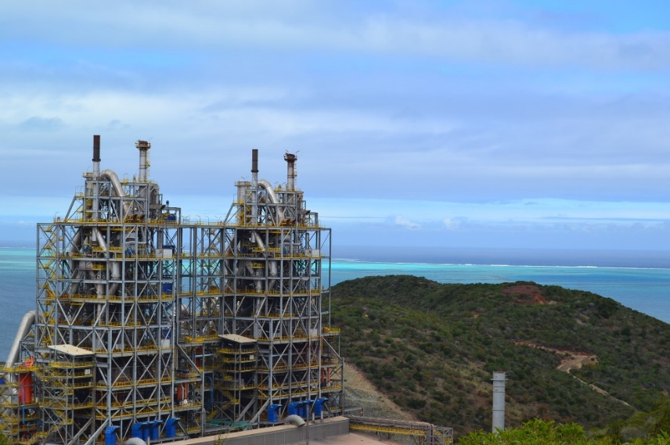

Since the 1980s, Kanak people of New Caledonia have been engaged in a process of decolonisation that seeks to break with the centre-periphery models of France/New-Caledonia or South Province / North Province, and have come to focus instead on their mutual “interdependencies” (Tjibaou, *La presénce kanak*, 1996). The Société minière du Sud Pacifique (SMSP), a local mining company whose major shareholder is the Northern Province, under the control of Kanak separatist parties, now owns 51% of an on-shore nickel project in New Caledonia and two more off-shore projects in South Korea and China. As in Papua New Guinea, mineral exports account for much of the value of New Caledonia’s total export; but unlike PNG, relatively few people live in poverty in New Caledonia, which has the second highest GDP of all France’s overseas regions. Building on ten months of fieldwork in the northern region of New Caledonia, I discuss recent Kanak engagement in the metallurgy-nickel sector, through the lens of the Koniambo project. Drawing on the work of Boltanski and Chiapello (*The New Spirit of Capitalism*, 2017), I want to consider how mining is imbued with the spirit of cultural production. In particular, this paper seeks: (1) to explore the resource-making and resource-management processes at Koniambo; 2) to deconstruct the idea that economic dynamism is necessarily opposed to the sacred; 3) to critically analyse the role of mining in political arrangements for New Caledonia’s future; and 4) to propose mining and mines as productive cultural and social sites. Looking beyond a post-colonial emphasis on exploitation, I’m interested in how indigenous people articulate the desire to be present and acknowledged within the global system.