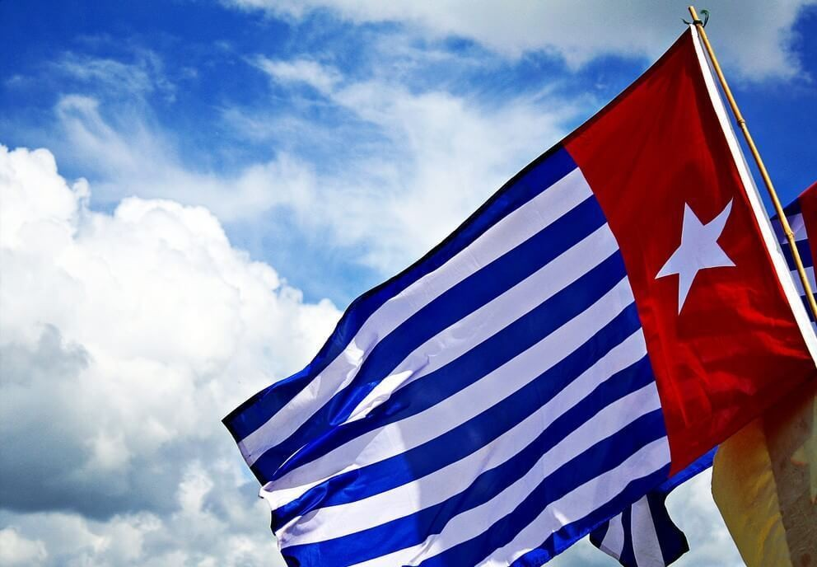

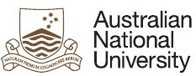**Insights on West Papua**

**Thursday 28 November, 6.00 – 8.00pm**

PANEL

**Speakers**

Dr Jacob Rumbiak Reverend James Bhagwan Dr Sophie Chao

Hipolitus Y.R Wangge

Associate Professor Chris Ballard Veronica Koman

# Location

Lecture Theatre 2, Hedley Bull Centre, 130 Garran Road

# Registration

Via Eventbrite: https://bit.ly/371RaJR

# This panel discussion brings together diverse voices and scholarships to support and highlight the ongoing debates and struggles of West Papua.

**Dr Jacob Rumbiak** is a West Papua academic, political leader and international spokesperson for the United Liberation Movement for West Papua (ULMWP).

**Reverend James Bhagwan** is an ordained minister of the Methodist Church in Fiji, and General Secretary of the Pacific Conference of Churches, representing approximately 80% of the Pacific people. He is a graduate of the Pacific Theological College and Methodist Theological University (Seoul) and is an advocate for climate justice - with particular emphasis on the ocean - gender equality, self-determination ecumenism and interreligious dialogue.

**Dr Sophie Chao** is a Postdoctoral Research Associate at the University of Sydney’s School of Philosophical and Historical Inquiry and the Charles Perkins Centre. Sophie completed a PhD at Macquarie University, based on ethnographic field work in West Papua examining deforestation and monocrop oil palm expansion and its reconfiguration of multispecies lifeworld of indigenous Marind communities. She is currently Secretary on the Executive Committee of the Australian Anthropological Association, and Co-Convenor of the Australian Food, Society, and Culture Network.

**Hipolitus Y.R Wangge** is a researcher in ethno-national conflicts, military politics and security studies in Southeast Asia and the Pacific region at the Marthinus Academy Jakarta. Commencing fieldwork in 2018 in Jayapura, Sorong, Fak-fak, and Wamena he has recently completed research on local civil society organizations in post-autonomy West Papua. Hipolitus has volunteered with internally displaced persons from Nduga due to the on-going armed conflict.

**Chris Ballard** is Associate Professor in Pacific History at the ANU, where his research interests focus on Indigenous forms of historical consciousness, community management of heritage, and the history of natural hazards. He first visited West Papua in 1987, but worked there more intensively from 1994- 2001.

**Veronica Koman** is an Indonesian human rights lawyer focusing on issues in West Papua. Her clients include West Papuans charged with treason for peacefully demanding their right to self-determination. She is now wanted by the Indonesian police on politicised charges, forcing her to live in exile. She was awarded the 2019 Sir Ronald Wilson Human Rights Award.



ANU Pacific Institute





ANU College of Asia & the Pacific

**EVENT SCHEDULE**

|  |  |
| --- | --- |
| TIME  6:00p.m  6:10pm  6:40p.m  6:55p.m  7:40p.m  8:00p.m | PRESENTATION  **Welcome to the Pacific Institute Annual Lecture and Acknowledgement of Country**  *By Miranda Forsyth, Convener of Pacific Institute and Event Moderator*  **Introductory Remarks by *Veronica Koman***  **Speaker 1: Dr Jacob Rumbiak**  *WEST PAPUA 1942 to 2020, the legals, the politics, and the only way forward.*  **Speaker 2: Chris Ballard**  *Racism directed at Papuans has featured prominently in the latest cycle of protest and repression, with allegations of racist language widely cited as the initial provocation that led to the protests. Racist views of Papuans have a long genealogy, extending back at least as far as the beginning of the 19th century, when English authors began to write pejoratively about Papuans by comparison with Malays. Dutch colonial attitudes further entrenched these views, which became institutionalised using non-Papuan teachers and administrators before World War II. This brief historical review tracks the origins of the current situation.*  **Discussion**  ***Moderated by Miranda Forsyth***  **Speaker 3: Reverend James Bhagwan**  *Negotiating Pacific Solidarity: the role of Churches and Civil Society*  *James will share on the work of Pacific Church and Civil Society in solidarity for West Papua. He will reflect on the recent engagement with Pacific Island Leaders at the Leaders' Meeting in Tuvalu. He will also share on the support for and role of amplifying the voice of Papuan Churches.*  **Speaker 4: Sophie Chao**  *Development, Deforestation, Dispossession: Indigenous Experiences in Merauke, West Papua: Over the last decade, vast swaths of forest and savannah in the West Papuan district of Merauke have been converted to agribusiness plantations in the name of national food security and regional economic development. Drawing from long-term ethnographic fieldwork in the region, this presentation explores how radical landscape conversions reconfigure the multispecies lifeworld, relations, and identities of indigenous Marind communities. It also examines the challenges posed by the expanding agribusiness sector to Marind's right as indigenous people to give or withhold their free, prior, and informed consent to land-based developments that affect their livelihoods, culture, and wellbeing.*  **Speaker 5: Hipolitus Wangge**  *Political Discrimination on Nduga’s Armed Conflict: 2019 is the bloodiest year for West Papuans and in West Papua. A series of armed conflicts, demonstrations, and riots have caused hundreds of civilian deaths and displaced thousands of indigenous West Papuans. The on-going armed conflict in Nduga, a central highland West Papua, displays a degree of political discrimination to overcome a long-running ethno-national conflict in West Papua*  **Final Discussion**  ***Moderated by Miranda Forsyth***  **Closing remarks by *Veronica Koman***  Everyone is welcome to join us for a Pacific dinner (served in the atrium) to mark the end of the year for the Pacific Institute |