Please join in the celebration as Tom Fisher launches

The Mary Joyce

dinghy to David’s yacht Kalitsah

10:00, Saturday 11 February 2006

ANU Sailing Club, Yarralumla Bay

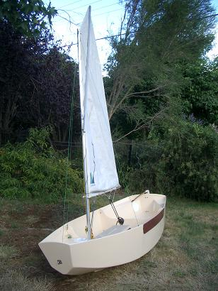

Please RSVP David Fisher:
tel: 04 31 06 87 01
email: sv-kalitsah@hotmail.com

