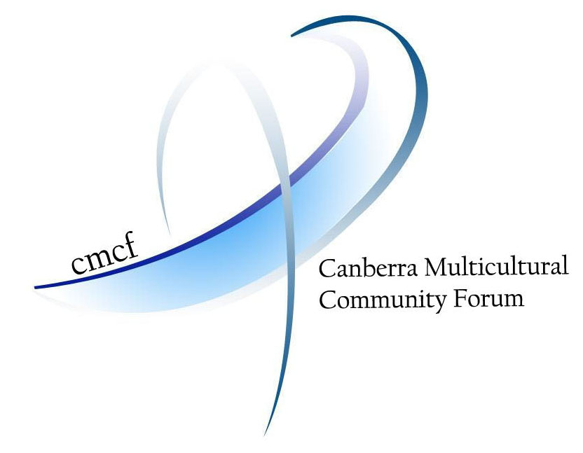


UNIVERSITY OF
CANBERRA
Australia’s Capital University

Canberra Region Languages Forum

WHEN? Sunday 18 May 2008, 1pm to 5pm

WHERE? Building 2, University of Canberra

A forum which brings together teachers, researchers, community groups, parents, students and others interested in maintaining and developing the bilingual and multilingual skills that Australians will need in the 21st century.

The aim is to share ideas and expertise to take action at the local level to increase awareness of the importance of other languages and to encourage people to learn, or to continue to develop, their language and cultural skills.

Topics to be discussed include developments since the first forum in October 2007, bilingual programs in ACT schools, ethnic schools, and collaboration between schools and multilingual community radio.

THE FORUM IS FREE

Everyone with an interest in language education is welcome

The forum will be opened by Ms Mary Porter AM, MLA, representing the ACT Chief Minister

To register, or for more information, please contact
Mandy Scott on (02) 6201 2073 or 0408 089 235 or email Mandy.Scott@canberra.edu.au

Languages Matter!
Official slogan for 2008 - International Year of Languages

