Upcoming Asian Art events at the National Gallery of Australia

New East Asian Gallery OPEN!!

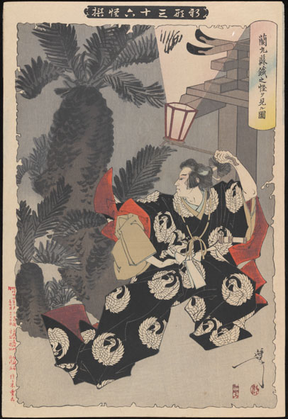

Thursday 29 May 12.45 pm
Sinister tales and ghostly images: floortalk
Lucie Folan, Assistant Curator, Asian Art, discusses Japanese woodblock prints by Tsukioka Yoshitoshi
Free
East Asian Gallery

Saturday 31 May 2 pm
Southeast Asian textiles: ‘Stitched in gold: ceremonial embroideries of maritime Southeast Asia’
Join Hwei-Fen Cheah, Asian art lecturer and curator, and explore the history, meanings and range of designs of gold thread embroideries from the Malay-speaking world in the Gallery’s collection
Free
Small Theatre

IMAGE: Yoshitoshi Tsukioka, Japan 1839 - 1892, Ranmaru and the mysterious sago palm [Ranmaru sotetsu no kai o miru zu]

